Fan led review of football governance

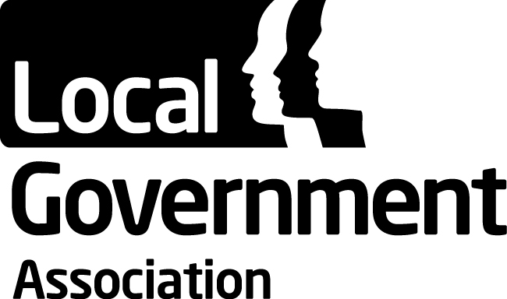 | Culture, Tourism and Sport Board
 | 21 June 2023

Purpose of Report
For information

Summary
In 2021 Tracey Crouch MP conducted a review of football governance. While the review and proposals do not directly affect local government, local clubs are a significant asset and influencer in communities. Councils can also play a role in supporting the welfare and future careers of players exiting the game - particularly because for many it can result in mental health problems or turning to crime or drugs. To date the CTS Board has maintained a watching brief on the review.
Several LGA members have committed to the Fair Game manifesto and the CTS Board received a presentation from at the March Board meeting. Following these discussions Tracey Crouch MP has been invited to the June Board meeting to discuss what councils can do in this space.
Is this report confidential? No

Recommendation/s
That the Board:
a) Note Tracey Crouch’s views on the direction of the game.
b) Identify the key role for local government in supporting the implementation of review.
c) Explore any cross-collaboration opportunities between the LGA and the APPG for Arts, Health and Wellbeing or the APPG for Women’s Football.

Contact details
Contact officer: Samantha Ramanah
Position: Adviser
Phone no: 07887 503 136
Email: Samantha.Ramanah@local.gov.uk

Tracey Crouch MP – biography

- Tracey Crouch was elected to represent the constituency of Chatham & Aylesford in 2010 with a majority of 6,069 and in doing so became the first Conservative MP for the seat.

- Tracey was the Minister for Sport, Civil Society and Loneliness for the Department for Digital, Culture, Media and Sport between 3 July 2017 - 1 November 2018 but resigned due to a delay over the introduction of reduced limits on the stakes of fixed odds betting terminals.

- In 2021 she delivered the Fan Led Review of Football governance. Of note, she is the chair of the All-Party Parliamentary Group on Arts, Health and Wellbeing, the Vice-Chair of the APPG for Football Supporters and the Chair of the All-Party Parliamentary Group on Women's Football. Tracey is a keen sports enthusiast and since 'retiring' from playing football has become a FA qualified football coach.
Background

- In response to several serious failings in a number of English football clubs the Government committed to deliver a fan-led review of football governance.

- Tracey Crouch MP delivered a Fan Led Review of Football governance. The report published in 2021 was based on engagement with supporters’ trusts, fan groups, women’s football representatives, football authorities, club owners, players representatives, and underrepresented interest groups, alongside over 20,000 fans responding to an online survey.

- The Review made several strategic recommendations primarily for a new Independent Regulator for English Football to be established to oversee the financial regulation and fairer distribution of funds across all levels of football and corporate governance and ensure new owners and directors are good custodians and qualified to run the club. There were recommendations for a greater focus on improving equality, diversity and inclusion in clubs and parity for women’s football.

- On 22 February 2023 the Government announced a series of measures which will respond to key recommendations in the review. These include:
7.1 A new independent regulator to help prevent repeat of financial failings

7.2 A strengthened owners’ and directors’ test to protect clubs and their fans from unscrupulous owners, including stronger due diligence on sources of wealth and a requirement for robust financial planning

7.3 Fans given greater say in running of clubs, and key heritage such as team names, badges. It will require clubs to seek regulator approval for any sale or relocation of the stadium, with fan engagement a major part of that process.

7.4 Powers to block English clubs from joining unpopular breakaway leagues like the European Super League

8. To date the CTS Board has maintained a watching brief on the review. Previous to this it published a guide for grassroots sports organisations on how to work effectively with local government in 2019. A guide on “Supporting community ownership” is due to be published shortly.
Areas for discussion
9. While the recommendations in the Fan Led Review of Football governance do not directly affect local government, there are two specific recommendations, which relate in part, to councils’ responsibilities for place shaping, training and skills development, safer communities and safeguarding. The two recommendations are:
9.1 Football clubs are a vital part of their local communities, in recognition of this there should be additional protection for key items of club heritage.
9.2 As an urgent matter, the welfare of players exiting the game needs to be better protected — particularly at a young age which for many can result in severe mental health issues or turning to crime. In October 2015 141 former players were in the British prison system. Around 90 per cent of these offenders were reported as being under the age of 25, with a similar percentage incarcerated for drug-related offences.
10.The Government’s Levelling Up the United Kingdom White Paper recognises the role club football plays in local communities and its social impact. Arguably, a well-run club could contribute towards achieving the Government’s Levelling Up missions for improving pride of place, increasing local employment and productivity, and reducing crime.
11. It is intended that future rounds of the Community Ownership Fund (COF) will enable more communities to take control of their local football grounds and other vital local sporting and community assets where they are at risk.
12. Under the Government’s measures, fans will be given greater say the strategic running of their club and help protect club heritage to stop owners changing names, badges and home shirt colours without consulting fans.
Questions to consider:
13. Question for Tracey: Many councils are considering how they can improve community engagement and involvement with their local football club. What did Tracey hear about the role of councils when undertaking the review?
14. Questions for the Board:
14.1 What is the role of local government in implementing these findings and strengthening the local game?
14.2 Do they need new powers or new funding in order to undertake this?

Implications for Wales
15. The review and response relates to England only. However, the LGA’s work on community ownership and engagement is applicable to Welsh authorities.

Financial Implications
16. This work has been delivered within existing budgets.

Equalities implications
17. The wider reforms include measures to make football more inclusive, with particular action to remove barriers to professionalisation in women’s football. The emphasis on support involvement in governance, should promote greater local connections, although will not in itself tackle the challenges of improving inclusion in football.

Next steps
18. The LGA team will act according to the Board’s directions

